Combinational Logic Design using VHDL

Brihat Ratna Bajracharya

*Department of Electronics and Computer Engineering, IOE Central Campus, Pulchowk  
Lalitpur, Nepal*

070bct513@ioe.edu.np

***Abstract*—VHDL is a language for describing digital electronic systems.** **VHDL is designed to fill a number of needs in the design process. Firstly, it allows description of the structure of a design, i.e. how it is decomposed into sub-designs, and how those sub-designs are interconnected. Secondly, it allows the specification of the function of designs using familiar programming language forms. Thirdly, as a result, it allows a design to be simulated before being manufactured, so that designers can quickly compare alternatives and test for correctness without the delay and expense of hardware prototyping.**

1. Introduction

VHDL stands for VHSIC (Very High Speed Integrated Circuit) Hardware Descriptive Language. It is used in electronic design automation to describe digital and mixed-signal systems such as field-programmable gate arrays and integrated circuits. VHDL can also be used as a general programming language. VHDL was originally developed at the behest of the US Department of Defence in order to document the behaviour of the ASICs that supplier companies were including in equipment. VHDL is influenced from Ada and Pascal. The initial release of VHDL was designed as per IEEE 1076 standard in 1987. The most commonly used VHDL version supported by CAD tools is IEEE 1076 1993.

1. *Features of VHDL*

* It is a hardware descriptive language used for design entry and simulation of digital circuits.
* It is an event-driven language: i.e. whenever an event occurs on signals in VHDL, it triggers the execution of a statement.
* It allows both concurrent as well as sequential modelling.
* It gives the flexibility to define data types that are specific to user needs apart from predefined types.
* It supports code reusability and code sharing via packages and user defined libraries.
* It is case-insensitive i.e. it does not differentiate between lowercase and uppercase letters.
* It is strongly typed language i.e. it does not support implicit conversion between data types.

1. *Levels of representation and abstraction*

A digital system can be represented at different levels of abstraction. This keeps the description and design of complex systems manageable.

1. Behavioral – The highest level of abstraction that describes a system in terms of what it does (or how it behaves) rather than in terms of its components and interconnection between them. A behavioral description specifies the relationship between the input and output signals. This could be a Boolean expression or a more abstract description such as the Register Transfer or Algorithmic level.
2. Structural – The structural level, on the other hand, describes a system as a collection of gates and components that are interconnected to perform a desired function. A structural description could be compared to a schematic of interconnected logic gates. It is a representation that is usually closer to the physical realization of a system.
3. *Lexical Elements*
4. Comments – VHDL comments start with two adjacent hyphens (‘--’) and extend to the end of the line. They have no part in the meaning of a VHDL description.
5. Identifiers – Identifiers in VHDL are used as reserved words and as programmer defined names. They must conform to the rule:

letter { [underscore] letter_or_digit}

Identifiers are case insensitive but underscore characters in identifiers are significant.

1. Numbers – Literal numbers may be expressed either in decimal or in a base between two and sixteen. If the literal includes a point, it represents a real number, otherwise it represents an integer. Decimal literals are defined by:

dec_literal ::= integer[.integer][exponent]

integer ::= digit {[underline]digit}

exponent ::= E [+] integer | E – integer

The base and the exponent are expressed in decimal. The exponent indicates the power of the base by which the literal is multiplied. The letters A to F (upper or lower case) are used as extended digits to represent 10 to 15.

1. Characters – Literal characters are formed by enclosing an ASCII character in single-quote marks (‘ ‘).
2. Strings – Literal strings of characters are formed by enclosing the characters in double-quote marks (“ “). To include a double-quote mark itself in a string, a pair of double-quote marks must be put together. A string can be used as a value for an object which is an array of characters.
3. Bit Strings – VHDL provides a convenient way of specifying literal values for arrays of type bit ('0's and '1's). The syntax is:

bit_string_literal ::= base_spec "bit_val"

base_spec ::= B | O | X

bit_val ::= ext_dig {[underscore] ext_dig}

Base specifier B stands for binary, O for octal and X for hexadecimal.

1. *Expressions and Operators*

An expression is a formula combining primaries with operators. Primaries include names of objects, literals, function calls and parenthesized expressions.

The logical operators **and**, **or**, **nand**, **nor**, **xor** and **not** operate on values of type **bit** or **boolean**, and also on one-dimensional arrays of these types. For array operands, the operation is applied between corresponding elements of each array, yielding an array of the same length as the result. For **bit** and **boolean** operands, **and**, **or**, **nand**, and **nor** are ‘short-circuit’ operators, i.e. they only evaluate their right operand if the left operand does not determine the result. So **and** and **nand** only evaluate the right operand if the left operand is true or '1', and **or** and **nor** only evaluate the right operand if the left operand is false or '0'.

The **relational operators** (=, /=, <, <=, > and >=) must have both operands of the same type, and yield **boolean** results. The **equality operators** (= and /=) can have operands of any type. For composite types, two values are equal if all of their corresponding elements are equal. The remaining operators must have operands which are scalar types or one-dimensional arrays of discrete types.

The **sign** **operators** (+ and –) and the **addition** (+) and **subtraction** (–) operators have their usual meaning on numeric operands. The **concatenation operator** (&) operates on one-dimensional arrays to form a new array with the contents of the right operand following the contents of the left operand. It can also concatenate a single new element to an array, or two individual elements to form an array. The concatenation operator is most commonly used with strings.

The **multiplication** (*) and **division** (/) operators work on integer, floating point and physical types. The **modulus** (mod) and **remainder** (rem) operators only work on integer types. The **absolute value** (abs) operator works on any numeric type. Finally, the **exponentiation** (**) operator can have an integer or floating point left operand, but must have an integer right operand. A negative right operand is only allowed if the left operand is a floating point number.

1. Sequential Statements

VHDL contains a number of facilities for modifying the state of objects and controlling the flow of execution of models.

1. Variable Assignment – As in other programming languages, a variable is given a new value using an assignment statement. The syntax is:

target := expression;

target ::= name | aggregate

In the simplest case, the target of the assignment is an object name, and the value of the expression is given to the named object. The object and the value must have the same base type. If the target of the assignment is an aggregate, then the elements listed must be object names, and the value of the expression must be a composite value of the same type as the aggregate.

1. If Statement – The if statement allows selection of statements to execute depending on one or more conditions. The syntax is:

**if** condition **then**

sequence_of_statements

{ **elsif** condition **then**

sequence_of_statements }

[ **else**

sequence_of_statements ]

**end if**;

The conditions are expressions resulting in boolean values. The conditions are evaluated successively until one found that yields the value true. In that case the corresponding statement list is executed. Otherwise, if the else clause is present, its statement list is executed.

1. Case Statement – The case statement allows selection of statements to execute depending on the value of a selection expression. The syntax is:

**case** expression is

case_statement_alternative

{ case_statement_alternative }

**end case**;

case_statement_alternative ::=

**when** choices =>

sequence_of_statements

choices ::= choice { | choice }

choice ::=

simple_expression

| discrete_range

| element_simple_name

| **others**

The selection expression must result in either a discrete type, or a one-dimensional array of characters. The alternative whose choice list includes the value of the expression is selected and the statement list executed.

1. Loop Statements – VHDL has a basic loop statement, which can be augmented to form the usual while and for loops seen in other programming languages. The syntax of the loop statement is:

[ loop_label : ]

[ iteration_scheme ] **loop**

sequence_of_statements

**end loop** [ loop_label ] ;

iteration_scheme ::=

**while** condition

| **for** loop_parameter_specification

parameter_specification ::=

identifier in discrete_range

If the iteration scheme is omitted, we get a loop which will repeat the enclosed statements indefinitely. An example of such a basic loop is:

**loop**

do_something;

**end loop**;

The while iteration scheme allows a test condition to be evaluated before each iteration. The iteration only proceeds if the test evaluates to true. If the test is false, the loop statement terminates. An example:

**while** index < length and str(index)/=' ' **loop**

index := index + 1;

**end loop**;

The for iteration scheme allows a specified number of iterations. The loop parameter specification declares an object which takes on successive values from the given range for each iteration of the loop. Within the statements enclosed in the loop, the object is treated as a constant, and so may not be assigned to. The object does not exist beyond execution of the loop statement. An example:

**for** item **in** 1 **to** last_item **loop**

table(item) := 0;

**end** loop;

1. Null Statement – The null statement has no effect. It may be used to explicitly show that no action is required in certain cases. It is most often used in case statements, where all possible values of the selection expression must be listed as choices, but for some choices no action is required.
2. Assertions – An assertion statement is used to verify a specified condition and to report if the condition is violated. The syntax is:

**assert** condition

[ **report** expression ]

[ **severity** expression ];

If the report clause is present, the result of the expression must be a string. This is a message which will be reported if the condition is false. If it is omitted, the default message is "Assertion violation". If the severity clause is present the expression must be of the type severity_level. If it is omitted, the default is error. A simulator may terminate execution if an assertion violation occurs and the severity value is greater than some implementation dependent threshold. Usually the threshold will be under user control.

1. *VHDL Structure*
2. Entity Declaration

The entity declaration defines the **name** of the entity and lists the input and output ports. The general form is:

**entity** NAME_OF_ENTITY **is**

**port** (signal_names: **mode type**;

signal_names: **mode type**;

: : :

signal_names: **mode type**);

**end** [NAME_OF_ENTITY] ;

**mode** is one of **in**, **out**, **buffer**, **inout** that indicate the signal direction and **type** is a built-in or user-defined signal type. Some signal types are **bit**, **bit_vector**, **std_logic**, **std_ulogic**, **std_logic_vector**, **time**, **real**, **std_ulogic_vector**, **boolean**, **integer**, **character.**

1. Architecture declaration

The architecture body specifies how the circuit operates and how it is implemented. The architecture body looks as follows:

**architecture** arch_name **of** entity **is**

-- Declarations

-- components declarations

-- signal declarations

-- constant declarations

-- type declarations

**begin**

-- Statements

:

**end** architecture_name;

1. Activity I

Write VHDL code to implement the logic circuit shown in figure, which has 4 inputs (x1, x2, x3, x4) and one output (f). Provide the following architectural styles:

Dataflow style

Behavioral style

Structural style

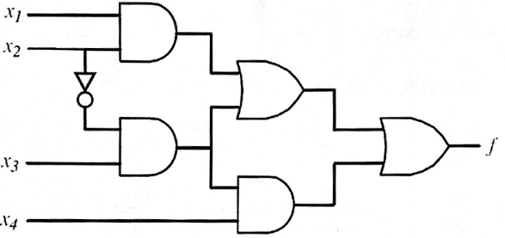

Write a VHDL test bench to verify the operation of the logic circuit. Provide a simulation waveform depicting all possible input cases

1. **Dataflow style**

LIBRARY IEEE;

USE IEEE.STD_LOGIC_1164.ALL;

ENTITY small_ckt IS PORT (

A, B, C, D: IN STD_LOGIC;

F: OUT STD_LOGIC

);

END small_ckt;

ARCHITECTURE dataflow OF small_ckt IS

BEGIN

F <= (((A AND B) OR (NOT B AND C)) OR ((NOT B AND C) AND D));

END dataflow;

1. **Behavioral style**

LIBRARY IEEE;

USE IEEE.STD_LOGIC_1164.ALL;

ENTITY small_ckt IS PORT (

A, B, C, D: IN STD_LOGIC;

F: OUT STD_LOGIC

);

END small_ckt;

ARCHITECTURE behavorial OF small_ckt IS

SIGNAL F1, F2, F3, F4: STD_LOGIC;

BEGIN

example: PROCESS(A,B,C,D,F1,F2,F3,F4)

BEGIN

F1 <= A AND B;

F2 <= NOT B AND C;

F3 <= F1 OR F2;

F4 <= F2 AND D;

F <= F3 OR F4;

END PROCESS example;

END behavorial;

1. **Structural style**

**[and1.vhd]**

LIBRARY IEEE;

USE IEEE.STD_LOGIC_1164.ALL;

ENTITY and1 IS PORT (

i1, i2: IN STD_LOGIC;

o1: OUT STD_LOGIC

);

END and1;

ARCHITECTURE dataflow OF and1 IS

BEGIN

o1 <= i1 AND i2;

END dataflow;

**[or1.vhd]**

LIBRARY IEEE;

USE IEEE.STD_LOGIC_1164.ALL;

ENTITY or1 IS PORT (

i1, i2: IN STD_LOGIC;

o1: OUT STD_LOGIC

);

END or1;

ARCHITECTURE dataflow OF or1 IS

BEGIN

o1 <= i1 OR i2;

END dataflow;

**[andnot.vhd]**

LIBRARY IEEE;

USE IEEE.STD_LOGIC_1164.ALL;

ENTITY andnot IS PORT (

i1, i2: IN STD_LOGIC;

o1: OUT STD_LOGIC

);

END andnot;

ARCHITECTURE dataflow OF andnot IS

BEGIN

o1 <= NOT i1 AND i2;

END dataflow;

**[small_ckt_structural.vhd]**

LIBRARY IEEE;

USE IEEE.STD_LOGIC_1164.ALL;

ENTITY small_ckt IS PORT (

A, B, C, D: IN STD_LOGIC;

F: OUT STD_LOGIC

);

END small_ckt;

ARCHITECTURE structural OF small_ckt IS

SIGNAL F1, F2, F3, F4: STD_LOGIC;

COMPONENT and1 IS PORT (

i1, i2: IN STD_LOGIC;

o1: OUT STD_LOGIC

);

END COMPONENT;

COMPONENT andnot IS PORT (

i1, i2: IN STD_LOGIC;

o1: OUT STD_LOGIC

);

END COMPONENT;

COMPONENT or1 IS PORT (

i1, i2: IN STD_LOGIC;

o1: OUT STD_LOGIC

);

END COMPONENT;

BEGIN

C1: and1 PORT MAP (i1 => A, i2 => B, o1 => F1);

C2: andnot PORT MAP (i1 => B, i2 => C, o1 => F2);

C3: or1 PORT MAP (i1 => F1, i2 => F2, o1 => F3);

C4: and1 PORT MAP (i1 => F2, i2 => D, o1 => F4);

C5: or1 PORT MAP (i1 => F3, i2 => F4, o1 => F);

END structural;

1. **Test bench**

LIBRARY IEEE;

USE IEEE.STD_LOGIC_1164.ALL;

USE IEEE.NUMERIC_STD.ALL;

ENTITY small_ckt_tb IS

END small_ckt_tb;

ARCHITECTURE behav OF small_ckt_tb IS

COMPONENT small_ckt

PORT(

A, B, C, D: IN STD_LOGIC;

F: OUT STD_LOGIC

);

END COMPONENT;

SIGNAL input_vector: STD_LOGIC_VECTOR( 3 DOWNTO 0) := "0000";

SIGNAL output: STD_LOGIC;

BEGIN

uut: small_ckt PORT MAP(

A => input_vector(3),

B => input_vector(2),

C => input_vector(1),

D => input_vector(0),

F => output

);

stim_proc: PROCESS

BEGIN

FOR index IN 0 TO 15 LOOP

input_vector <= std_logic_vector(to_unsigned(index,4));

WAIT FOR 50 ns;

END LOOP;

END PROCESS;

END behavioral;

Discussion:

Here, we need to implement given logic circuit in VHDL. In dataflow style, we simply created four input signal along with single output and by using logical operators we simply wrote the expression to produce output.

Behavior style is also similarly done. Only difference in behavioural style is that we called a process to execute the operation and to produce the output.

In structural style, we first created three components namely, **and1**, **or1** and **andnot**. Then these components are used to make structure of the logic circuit. While writing structure PORT MAP is used to connect signals to the port. Components are used to perform each operation separately before producing the output.

Output:

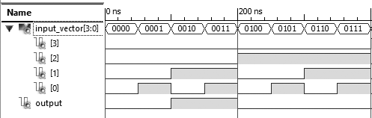

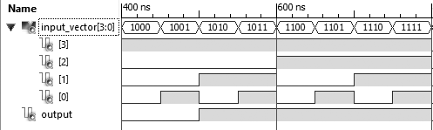

1. Activity II

Write VHDL code to design a logic circuit that implements the truth table of BCD-to-Gray code converter. Use Karnaugh maps to simplify the output functions. Provide the following architectural styles:

Dataflow style

Behavioral style

Structural style

TABLE – I

Truth Table of BCD-to-Gray Code Converter

|  |  |  |  |  |  |  |  |
| --- | --- | --- | --- | --- | --- | --- | --- |
| **BCD Numbers** | | | | **Gray Code Numbers** | | | |
| **X3** | **X2** | **X1** | **X0** | **Y3** | **Y2** | **Y1** | **Y0** |
| 0 | 0 | 0 | 0 | 0 | 0 | 0 | 0 |
| 0 | 0 | 0 | 1 | 0 | 0 | 0 | 1 |
| 0 | 0 | 1 | 0 | 0 | 0 | 1 | 1 |
| 0 | 0 | 1 | 1 | 0 | 0 | 1 | 0 |
| 0 | 1 | 0 | 0 | 0 | 1 | 1 | 0 |
| 0 | 1 | 0 | 1 | 0 | 1 | 1 | 1 |
| 0 | 1 | 1 | 0 | 0 | 1 | 0 | 1 |
| 0 | 1 | 1 | 1 | 0 | 1 | 0 | 0 |
| : | : | : | : | : | : | : | : |
| 1 | 1 | 1 | 1 | 1 | 0 | 0 | 0 |

Write a VHDL test bench to verify the operation of the logic circuit. Provide a simulation waveform depicting all possible input cases.

1. **Karnaugh Map Simplification**

|  |  |  |  |  |
| --- | --- | --- | --- | --- |
| **X1X0 🡪**  **X3X2↓** | **00** | **01** | **11** | **10** |
| **00** | 0 | 0 | 0 | 0 |
| **01** | 0 | 0 | 0 | 0 |
| **11** | 1 | 1 | 1 | 1 |
| **10** | 1 | 1 | 1 | 1 |

|  |  |  |  |  |
| --- | --- | --- | --- | --- |
| **X1X0 🡪**  **X3X2↓** | **00** | **01** | **11** | **10** |
| **00** | 0 | 0 | 0 | 0 |
| **01** | 1 | 1 | 1 | 1 |
| **11** | 0 | 0 | 0 | 0 |
| **10** | 1 | 1 | 1 | 1 |

k-map for Y3 k-map for Y2

Y3 = X3 Y2 = X3 XOR X2

|  |  |  |  |  |
| --- | --- | --- | --- | --- |
| **X1X0 🡪**  **X3X2↓** | **00** | **01** | **11** | **10** |
| **00** | 0 | 0 | 1 | 1 |
| **01** | 1 | 1 | 0 | 0 |
| **11** | 1 | 1 | 0 | 0 |
| **10** | 0 | 0 | 1 | 1 |

|  |  |  |  |  |
| --- | --- | --- | --- | --- |
| **X1X0 🡪**  **X3X2↓** | **00** | **01** | **11** | **10** |
| **00** | 0 | 1 | 0 | 1 |
| **01** | 0 | 1 | 0 | 1 |
| **11** | 0 | 1 | 0 | 1 |
| **10** | 0 | 1 | 0 | 1 |

k-map for Y1 k-map for Y2

Y1 = X2 XOR X1 Y0 = X1 XOR X0

1. **Dataflow style**

LIBRARY IEEE;

USE IEEE.STD_LOGIC_1164.ALL;

ENTITY bcd_gray IS PORT (

X3, X2, X1, X0: IN STD_LOGIC;

Y3, Y2, Y1, Y0: OUT STD_LOGIC

);

END bcd_gray;

ARCHITECTURE dataflow OF bcd_gray IS

BEGIN

Y3 <= X3;

Y2 <= X2 XOR X3;

Y1 <= X1 XOR X2;

Y0 <= X0 XOR X1;

END dataflow;

1. **Behavioral style**

LIBRARY IEEE;

USE IEEE.STD_LOGIC_1164.ALL;

ENTITY bcd_gray IS PORT (

X3, X2, X1, X0: IN STD_LOGIC;

Y3, Y2, Y1, Y0: OUT STD_LOGIC

);

END bcd_gray;

ARCHITECTURE behavorial OF bcd_gray IS

BEGIN

PROCESS(X3,X2,X1,X0)

BEGIN

Y3 <= X3;

Y2 <= X2 XOR X3;

Y1 <= X1 XOR X2;

Y0 <= X0 XOR X1;

END PROCESS

END behavorial;

1. **Structural style (using only NOR gates)**

**[xor_nor.vhd]**

LIBRARY IEEE;

USE IEEE.STD_LOGIC_1164.ALL;

ENTITY xor_nor IS PORT (

a, b: IN STD_LOGIC;

o: OUT STD_LOGIC

);

END xor_nor;

ARCHITECTURE behavorial OF xor_nor IS

SIGNAL nota, notb, xnorab: STD_LOGIC;

BEGIN

xor_nor: PROCESS (a,b,nota,notb,xnorab)

BEGIN

nota <= a NOR a;

notb <= b NOR b;

xnorab <= (a NOR notb) NOR

(nota NOR b);

o <= xnorab NOR xnorab;

END PROCESS xor_nor;

END behavorial;

**[bcd_gray_structural.vhd]**

LIBRARY IEEE;

USE IEEE.STD_LOGIC_1164.ALL;

ENTITY bcd_gray IS PORT (

X3, X2, X1, X0: IN STD_LOGIC;

Y3, Y2, Y1, Y0: OUT STD_LOGIC

);

END bcd_gray;

ARCHITECTURE structural OF bcd_gray IS

COMPONENT xor_nor IS PORT (

a, b: IN STD_LOGIC;

o: OUT STD_LOGIC

);

END COMPONENT;

BEGIN

C0: xor_nor PORT MAP (a => X3, b => '0', o => Y3);

C1: xor_nor PORT MAP (a => X3, b => X2, o => Y2);

C2: xor_nor PORT MAP (a => X2, b => X1, o => Y1);

C3: xor_nor PORT MAP (a => X1, b => X0, o => Y0);

END structural;

1. **Test Bench**

LIBRARY IEEE;

USE IEEE.STD_LOGIC_1164.ALL;

USE IEEE.NUMERIC_STD.ALL;

ENTITY bcd_gray_tb IS

END bcd_gray_tb;

ARCHITECTURE behavioral OF bcd_gray_tb IS

COMPONENT bcd_gray

PORT(

X3, X2, X1, X0: IN STD_LOGIC;

Y3, Y2, Y1, Y0: OUT STD_LOGIC;

);

END COMPONENT;

SIGNAL input_vector: STD_LOGIC_VECTOR( 3 DOWNTO 0) := "0000";

SIGNAL output_vector: STD_LOGIC_VECTOR( 3 DOWNTO 0) := "0000";

BEGIN

uut: bcd_gray PORT MAP(

X3 => input_vector(3),

X2 => input_vector(2),

X1 => input_vector(1),

X0 => input_vector(0),

Y3 => output_vector(3),

Y2 => output_vector(2),

Y1 => output_vector(1),

Y0 => output_vector(0)

);

stim_proc: PROCESS

BEGIN

FOR index IN 0 TO 15 LOOP

input_vector <= std_logic_vector(to_unsigned(index,4));

WAIT FOR 50 ns;

END LOOP;

END PROCESS;

END behavioral;

Discussion:

Second activity is a BCD to Gray code converter. Using the given truth table (though incomplete), expression for Y3, Y2, Y1, Y0 is calculated using Karnaugh simplification. This expression was used directly in dataflow as well as behavioural style. But in case of structural style, we were required to use NOR gate for each operation. So, we created XOR gate using NOR gate only and used it in structural description of the converter.

Output:

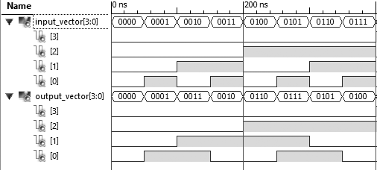

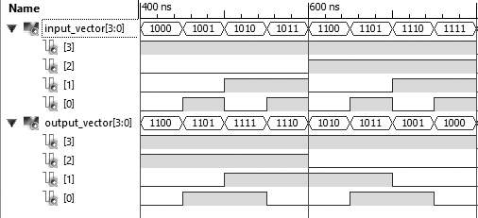

1. Activity III

Write VHDL code to implement the logic function (f) with three input variables x1, x2, x3. The function (f) is equal to 1 if and only if two variables are equal to 1; otherwise, it is equal to zero. Draw a truth table for the function (f), and use Karnaugh maps to simplify. Provide the following architectural styles:

Dataflow style

Behavioral style

Structural style (using only NAND gates)

Write a VHDL test bench to verify the operation of the logic circuit. Provide a simulation waveform depicting all possible input cases.

1. **Truth Table**

TABLE – II

Truth Table for Activity III

|  |  |  |  |
| --- | --- | --- | --- |
| **Input** | | | **Output** |
| **X2** | **X1** | **X0** | **Y3** |
| 0 | 0 | 0 | 0 |
| 0 | 0 | 1 | 0 |
| 0 | 1 | 0 | 0 |
| 0 | 1 | 1 | 1 |
| 1 | 0 | 0 | 0 |
| 1 | 0 | 1 | 1 |
| 1 | 1 | 0 | 1 |
| 1 | 1 | 1 | 0 |

1. **Karnaugh Map Simplification**

k-map for Y

Y = X1X2X3’ + X1X2’X3 + X1’X2X3

|  |  |  |  |  |
| --- | --- | --- | --- | --- |
| **X1X0 🡪**  **X2↓** | **00** | **01** | **11** | **10** |
| **0** | 0 | 0 | 1 | 0 |
| **1** | 0 | 1 | 0 | 1 |

1. **Dataflow style**

LIBRARY IEEE;

USE IEEE.STD_LOGIC_1164.ALL;

ENTITY func IS PORT (

X1, X2, X3: IN STD_LOGIC;

F: OUT STD_LOGIC

);

END func;

ARCHITECTURE dataflow OF func IS

BEGIN

F <= (X1 AND X2 AND NOT X3) OR (X3 AND (X1 XOR X2));

END dataflow;

1. **Behavioral style**

LIBRARY IEEE;

USE IEEE.STD_LOGIC_1164.ALL;

ENTITY func IS PORT (

X1, X2, X3: IN STD_LOGIC;

F: OUT STD_LOGIC

);

END func;

ARCHITECTURE behavioral OF func IS

SIGNAL A1, A2, A3: STD_LOGIC;

BEGIN

PROCESS (X1,X2,X3,A1,A2,A3)

BEGIN

A1 <= X1 AND X2 AND NOT X3;

A2 <= X1 XOR X2;

A3 <= A2 AND X3;

F <= A1 OR A3;

END PROCESS;

END behavioral;

1. **Structural style**

**[func_and1.vhd]**

LIBRARY IEEE;

USE IEEE.STD_LOGIC_1164.ALL;

ENTITY and1 IS PORT (

a, b, c: IN STD_LOGIC;

o: OUT STD_LOGIC

);

END and1;

ARCHITECTURE behavorial OF and1 IS

SIGNAL F1, F2, F3, F4: STD_LOGIC;

BEGIN

PROCESS (a,b,c,F1,F2,F3,F4)

BEGIN

F1 <= a NAND a;

F2 <= F1 NAND b;

F3 <= F2 NAND F2;

F4 <= F3 NAND c;

o <= F4 NAND F4;

END PROCESS;

END behavorial;

**[func_or1.vhd]**

LIBRARY IEEE;

USE IEEE.STD_LOGIC_1164.ALL;

ENTITY or1 IS PORT (

a, b, c: IN STD_LOGIC;

o: OUT STD_LOGIC

);

END or1;

ARCHITECTURE behavorial OF or1 IS

SIGNAL G1, G2, G3, G4, G5: STD_LOGIC;

BEGIN

PROCESS (a,b,c,G1,G2,G3,G4,G5)

BEGIN

G1 <= a NAND a;

G2 <= b NAND b;

G3 <= G1 NAND G2;

G4 <= G3 NAND G3;

G5 <= c NAND c;

o <= G4 NAND G5;

END PROCESS;

END behavorial;

**[func_structural.vhd]**

LIBRARY IEEE;

USE IEEE.STD_LOGIC_1164.ALL;

ENTITY func IS PORT (

X3, X2, X1: IN STD_LOGIC;

F: OUT STD_LOGIC

);

END func;

ARCHITECTURE structural OF func IS

SIGNAL A1, A2, A3: STD_LOGIC;

COMPONENT and1 IS PORT (

a, b, c: IN STD_LOGIC;

o: OUT STD_LOGIC

);

END COMPONENT;

COMPONENT or1 IS PORT (

a, b, c: IN STD_LOGIC;

o: OUT STD_LOGIC

);

END COMPONENT;

BEGIN

N1: and1 PORT MAP (a => X1, b => X2, c => X3, o => A1);

N2: and1 PORT MAP (a => X2, b => X3, c => X1, o => A2);

N3: and1 PORT MAP (a => X3, b => X1, c => X2, o => A3);

N4: or1 PORT MAP (a => A1, b => A2, c => A3, o => F);

END structural;

1. **Test Bench**

LIBRARY IEEE;

USE IEEE.STD_LOGIC_1164.ALL;

USE IEEE.NUMERIC_STD.ALL;

ENTITY func_tb IS

END func_tb;

ARCHITECTURE behavioral OF func_tb IS

COMPONENT func

PORT (

X1, X2, X3: IN STD_LOGIC;

F: OUT STD_LOGIC

);

END COMPONENT;

SIGNAL input: STD_LOGIC_VECTOR(2 DOWNTO 0):= "000";

SIGNAL output: STD_LOGIC :='0';

BEGIN

uut: func PORT MAP (

X3 => input(2),

X2 => input(1),

X1 => input(0),

F => output

);

stim_proc: PROCESS

BEGIN

FOR index IN 0 TO 7 LOOP

input <= STD_LOGIC_VECTOR (TO_UNSIGNED(index,3));

WAIT FOR 50 ns;

END LOOP;

END PROCESS;

END behavioral;

Discussion:

This activity is similar to previous activity. Before proceeding, we need to make truth table for given problem for all possible cases which we did and then used the expression generated from the truth table in dataflow and behavioural style. In structural style, three basic gates AND, OR, and NOT were made using NAND gate as instructed. NOT gate was not separately made but calculated inside AND and OR gate. These components were then used in structural description of the logic circuit.

Output:

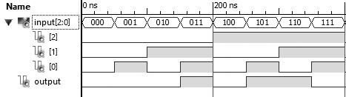

1. Activity IV

Write VHDL code to implement the implicit sum of products (SOP) and product of sum (POS) logic functions

F1(x1,x2,x3,x4) = ∑ (m0,m1,m4,m5,m8,m9,m14,m15)

F2(x1,x2,x3,x4) = ∏ (M0,M1,M5,M8,M9,M13,M15)

Draw the truth tables for the functions, and use Karnaugh maps to simplify. Provide the following architectural styles:

Dataflow style

Behavioral style

Structural style (using only NAND gates)

Write a VHDL test bench to verify the operation of the logic circuit. Provide a simulation waveform depicting all possible input cases.

1. **Truth Table**

TABLE – III

Truth Table for Activity IV

|  |  |  |  |  |  |
| --- | --- | --- | --- | --- | --- |
| **Input** | | | | **Output** | |
| **X3** | **X2** | **X1** | **X0** | **F1** | **F2** |
| 0 | 0 | 0 | 0 | 1 | 0 |
| 0 | 0 | 0 | 1 | 1 | 0 |
| 0 | 0 | 1 | 0 | 0 | 1 |
| 0 | 0 | 1 | 1 | 0 | 1 |
| 0 | 1 | 0 | 0 | 1 | 1 |
| 0 | 1 | 0 | 1 | 1 | 0 |
| 0 | 1 | 1 | 0 | 0 | 1 |
| 0 | 1 | 1 | 1 | 0 | 1 |
| 1 | 0 | 0 | 0 | 1 | 0 |
| 1 | 0 | 0 | 1 | 1 | 0 |
| 1 | 0 | 1 | 0 | 0 | 1 |
| 1 | 0 | 1 | 1 | 0 | 1 |
| 1 | 1 | 0 | 0 | 0 | 1 |
| 1 | 1 | 0 | 1 | 0 | 0 |
| 1 | 1 | 1 | 0 | 1 | 1 |
| 1 | 1 | 1 | 1 | 1 | 0 |

1. **Karnaugh Map Simplification**

|  |  |  |  |  |
| --- | --- | --- | --- | --- |
| **X1X0 🡪**  **X3X2↓** | **00** | **01** | **11** | **10** |
| **00** | 1 | 1 | 0 | 0 |
| **01** | 1 | 1 | 0 | 0 |
| **11** | 0 | 0 | 1 | 1 |
| **10** | 1 | 1 | 0 | 0 |

|  |  |  |  |  |
| --- | --- | --- | --- | --- |
| **X1X0 🡪**  **X3X2↓** | **00** | **01** | **11** | **10** |
| **00** | 0 | 0 | 1 | 1 |
| **01** | 1 | 0 | 1 | 1 |
| **11** | 1 | 0 | 0 | 1 |
| **10** | 0 | 0 | 1 | 1 |

k-map for F1 k-map for F2

F1 = X1’X3’ + X2’X3’ + X1X2X3 F2 = (X3 + X4’) (X2 + X3)

(X1’+X2’+X4’)

1. **Dataflow style (for F1)**

LIBRARY IEEE;

USE IEEE.STD_LOGIC_1164.ALL;

ENTITY sop IS PORT (

X1, X2, X3, X4: IN STD_LOGIC;

Y: OUT STD_LOGIC

);

END sop;

ARCHITECTURE dataflow OF sop IS

BEGIN

Y <= (NOT X1 AND NOT X3) OR (NOT X2

AND NOT X3) OR (X1 AND X2 AND X3);

END dataflow;

1. **Behavioral style (for F1)**

LIBRARY IEEE;

USE IEEE.STD_LOGIC_1164.ALL;

ENTITY sop IS PORT (

X1, X2, X3, X4: IN STD_LOGIC;

Y: OUT STD_LOGIC

);

END sop;

ARCHITECTURE behavorial OF sop IS

BEGIN

PROCESS(X1,X2,X3,X4)

BEGIN

Y <= (NOT X1 AND NOT X3) OR (NOT X2

AND NOT X3) OR (X1 AND X2 AND X3);

END PROCESS;

END behavorial;

1. **Structural style (using only NAND gates) (for F1)**

**[sop_and.vhd]**

LIBRARY IEEE;

USE IEEE.STD_LOGIC_1164.ALL;

ENTITY and1 IS PORT (

a, b: IN STD_LOGIC;

o: OUT STD_LOGIC

);

END and1;

ARCHITECTURE behavorial OF and1 IS

SIGNAL F: STD_LOGIC;

BEGIN

PROCESS (a,b,F)

BEGIN

F <= a NAND b;

o <= F NAND F;

END PROCESS;

END behavorial;

**[sop_or.vhd]**

LIBRARY IEEE;

USE IEEE.STD_LOGIC_1164.ALL;

ENTITY or1 IS PORT (

a,b: IN STD_LOGIC;

o: OUT STD_LOGIC

);

END or1;

ARCHITECTURE behavorial OF or1 IS

SIGNAL G1,G2: STD_LOGIC;

BEGIN

PROCESS (a,b,G1,G2)

BEGIN

G1 <= a NAND a;

G2 <= b NAND b;

o <= G1 NAND G2;

END PROCESS;

END behavorial;

**[sop_not.vhd]**

LIBRARY IEEE;

USE IEEE.STD_LOGIC_1164.ALL;

ENTITY not1 IS PORT (

a: IN STD_LOGIC;

o: OUT STD_LOGIC

);

END not1;

ARCHITECTURE behavorial OF not1 IS

BEGIN

PROCESS (a)

BEGIN

o <= a NAND a;

END PROCESS;

END behavorial;

**[sop_structural.vhd]**

LIBRARY IEEE;

USE IEEE.STD_LOGIC_1164.ALL;

ENTITY sop IS PORT (

X1, X2, X3, X4: IN STD_LOGIC;

Y: OUT STD_LOGIC

);

END sop;

ARCHITECTURE structural OF sop IS

SIGNAL NX1, NX2, NX3, F: STD_LOGIC;

SIGNAL I1, I2, I3, I4: STD_LOGIC;

COMPONENT not1 IS PORT (

a: IN STD_LOGIC;

o: OUT STD_LOGIC

);

END COMPONENT;

COMPONENT and1 IS PORT (

a, b: IN STD_LOGIC;

o: OUT STD_LOGIC

);

END COMPONENT;

COMPONENT or1 IS PORT (

a, b: IN STD_LOGIC;

o: OUT STD_LOGIC

);

END COMPONENT;

BEGIN

N1: not1 PORT MAP (a => X1, o => NX1);

N2: not1 PORT MAP (a => X2, o => NX2);

N3: not1 PORT MAP (a => X3, o => NX3);

A1: and1 PORT MAP (a => NX1, b => X3,

o => I1);

A2: and1 PORT MAP (a => NX2, b =>

NX3, o => I2);

A3: and1 PORT MAP (a => X1, b => X2,

o => I3);

A4: and1 PORT MAP (a => I3, b => X3,

o => I4);

O1: or1 PORT MAP (a => I1, b => I2,

o => F);

O2: or1 PORT MAP (a => F, b => I4, o

=> Y);

END structural;

1. **Dataflow style (for F2)**

LIBRARY IEEE;

USE IEEE.STD_LOGIC_1164.ALL;

ENTITY pos IS PORT (

X1, X2, X3, X4: IN STD_LOGIC;

Y: OUT STD_LOGIC

);

END pos;

ARCHITECTURE dataflow OF pos IS

BEGIN

Y <= (X3 OR NOT X4) AND (X2 OR X3)

AND (NOT X1 OR NOT X2 OR NOT X4);

END dataflow;

1. **Behavioral style (for F2)**

LIBRARY IEEE;

USE IEEE.STD_LOGIC_1164.ALL;

ENTITY pos IS PORT (

X1, X2, X3, X4: IN STD_LOGIC;

Y: OUT STD_LOGIC

);

END pos;

ARCHITECTURE behavorial OF pos IS

BEGIN

PROCESS(X1,X2,X3,X4)

BEGIN

Y <= (X3 OR NOT X4) AND (X2 OR X3)

AND (NOT X1 OR NOT X2 OR NOT X4);

END PROCESS;

END behavorial;

1. **Structural style (using only NAND gates) (for F2)**

**[pos_and.vhd]**

LIBRARY IEEE;

USE IEEE.STD_LOGIC_1164.ALL;

ENTITY and1 IS PORT (

a, b: IN STD_LOGIC;

o: OUT STD_LOGIC

);

END and1;

ARCHITECTURE behavorial OF and1 IS

SIGNAL F: STD_LOGIC;

BEGIN

PROCESS (a,b,F)

BEGIN

F <= a NAND b;

o <= F NAND F;

END PROCESS;

END behavorial;

**[pos_or.vhd]**

LIBRARY IEEE;

USE IEEE.STD_LOGIC_1164.ALL;

ENTITY or1 IS PORT (

a, b: IN STD_LOGIC;

o: OUT STD_LOGIC

);

END or1;

ARCHITECTURE behavorial OF or1 IS

SIGNAL G1, G2: STD_LOGIC;

BEGIN

PROCESS (a,b,G1,G2)

BEGIN

G1 <= a NAND a;

G2 <= b NAND b;

o <= G1 NAND G2;

END PROCESS;

END behavorial;

**[pos_not.vhd]**

LIBRARY IEEE;

USE IEEE.STD_LOGIC_1164.ALL;

ENTITY not1 IS PORT (

a: IN STD_LOGIC;

o: OUT STD_LOGIC

);

END not1;

ARCHITECTURE behavorial OF not1 IS

BEGIN

PROCESS (a)

BEGIN

o <= a NAND a;

END PROCESS;

END behavorial;

**[pos_structural.vhd]**

LIBRARY IEEE;

USE IEEE.STD_LOGIC_1164.ALL;

ENTITY pos IS PORT (

X1, X2, X3, X4: IN STD_LOGIC;

Y: OUT STD_LOGIC

);

END pos;

ARCHITECTURE structural OF pos IS

SIGNAL NX1, NX2, NX4, F: STD_LOGIC;

SIGNAL I1, I2, I3, I4: STD_LOGIC;

COMPONENT not1 IS PORT (

a: IN STD_LOGIC;

o: OUT STD_LOGIC

);

END COMPONENT;

COMPONENT and1 IS PORT (

a, b: IN STD_LOGIC;

o: OUT STD_LOGIC

);

END COMPONENT;

COMPONENT or1 IS PORT (

a, b: IN STD_LOGIC;

o: OUT STD_LOGIC

);

END COMPONENT;

BEGIN

N1: not1 PORT MAP (a => X1, o => NX1);

N2: not1 PORT MAP (a => X2, o => NX2);

N3: not1 PORT MAP (a => X4, o => NX4);

O1: or1 PORT MAP (a => X3, b => NX4,

o => I1);

O2: or1 PORT MAP (a => X2, b => X3,

o => I2);

O3: or1 PORT MAP (a => NX1, b => NX2,

o => I3);

O4: or1 PORT MAP (a => I3, b => NX4,

o => I4);

A1: and1 PORT MAP (a => I1, b => I2,

o => F);

A2: and1 PORT MAP (a => F, b => I4,

o => Y);

END structural;

1. **Test Bench**

LIBRARY IEEE;

USE IEEE.STD_LOGIC_1164.ALL;

USE IEEE.NUMERIC_STD.ALL;

ENTITY sop_tb IS

END sop_tb;

ARCHITECTURE behavioral OF sop_tb IS

COMPONENT sop

PORT(

X1, X2, X3, X4: IN STD_LOGIC;

Y: OUT STD_LOGIC

);

END COMPONENT;

SIGNAL input_vector: STD_LOGIC_VECTOR(3 DOWNTO 0) := "0000";

SIGNAL output: STD_LOGIC:= '0';

BEGIN

uut: sop PORT MAP(

X1 => input_vector(3),

X2 => input_vector(2),

X3 => input_vector(1),

X4 => input_vector(0),

Y => output

);

stim_proc: PROCESS

BEGIN

FOR index IN 0 TO 15 LOOP

input_vector <= std_logic_vector(to_unsigned(index,4));

WAIT FOR 50 ns;

END LOOP;

END PROCESS;

END behavioral;

Discussion:

Instead of logic circuit, this question provided us the sum of product and product of sum function. In this activity, we first drew the truth table for each function and using Karnaugh Map, simplified to shorter expression. This expression was directly used in dataflow and behavioural style using logical operators. In structural style, basic gates were made as components using NAND gate only. These components were then used in structural description of the SOP and POS function.

Output (for sum of product, F1):

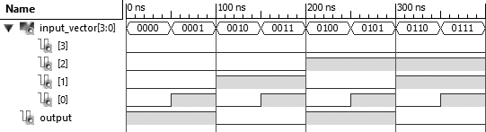

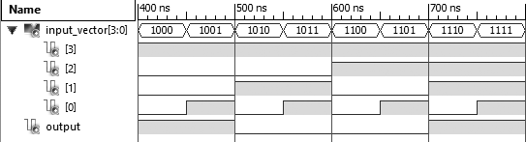

Output (for product of sun, F2):

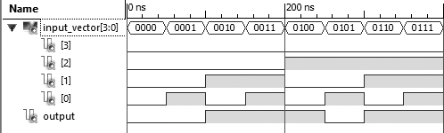

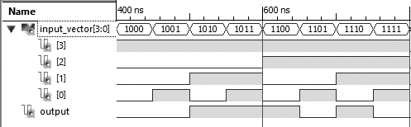

1. Activity V

Write VHDL code to implement a 2:1 MUX having inputs x1 and x2, select line s and output y.

`TABLE – IV

Truth Table for 2:1 Multiplexer

|  |  |  |  |
| --- | --- | --- | --- |
| **Select Line** | **Input Lines** | | **Output Line** |
| **S** | **X2** | **X1** | **Y** |
| 0 | 0 | 0 | 0 |
| 0 | 0 | 1 | 1 |
| 0 | 1 | 0 | 0 |
| 0 | 1 | 1 | 1 |
| 1 | 0 | 0 | 0 |
| 1 | 0 | 1 | 0 |
| 1 | 1 | 0 | 1 |
| 1 | 1 | 1 | 1 |

Provide the following architectural implementation:

Using WITH-SELECT statement

Using WHEN-ELSE statement

Using IF-THEN-ELSE statement

Write a VHDL test bench to verify the operation of the logic circuit. Provide a simulation waveform depicting all possible input cases.

1. **Using WITH-SELECT statement**

LIBRARY IEEE;

USE IEEE.STD_LOGIC_1164.ALL;

ENTITY mux2to1 IS PORT (

S, X1, X2: IN STD_LOGIC;

Y: OUT STD_LOGIC

);

END mux2to1;

ARCHITECTURE dataflow OF mux2to1 IS

BEGIN

WITH (NOT S AND X1) OR (S AND X2) SELECT

Y <= '1' WHEN '1',

'0' WHEN '0',

'0' WHEN OTHERS;

END dataflow;

1. **Using WHEN-ELSE statement**

LIBRARY IEEE;

USE IEEE.STD_LOGIC_1164.ALL;

ENTITY mux2to1 IS PORT (

S, X1, X2: IN STD_LOGIC;

Y: OUT STD_LOGIC

);

END mux2to1;

ARCHITECTURE dataflow OF mux2to1 IS

BEGIN

Y <= '1' WHEN ((NOT S AND X1) OR (S

AND X2)) = '1' ELSE

` '0';

END dataflow;

1. **Using IF-THEN-ELSE statement**

LIBRARY IEEE;

USE IEEE.STD_LOGIC_1164.ALL;

ENTITY mux2to1 IS PORT (

S, X1, X2: IN STD_LOGIC;

Y: OUT STD_LOGIC

);

END mux2to1;

ARCHITECTURE behavioral OF mux2to1 IS

BEGIN

PROCESS (S,X1,X2)

BEGIN

IF ((NOT S AND X1) OR (S AND X2)) =

'1' THEN Y <= '1';

ELSE Y <= '0';

END IF;

END PROCESS;

END behavioral;

1. **Test Bench**

LIBRARY IEEE;

USE IEEE.STD_LOGIC_1164.ALL;

USE IEEE.NUMERIC_STD.ALL;

ENTITY mux2to1_tb IS

END mux2to1_tb;

ARCHITECTURE behavioral OF mux2to1_tb IS

COMPONENT mux2to1

PORT (

S, X1, X2: IN STD_LOGIC;

Y: OUT STD_LOGIC

);

END COMPONENT;

SIGNAL input: STD_LOGIC_VECTOR(2 DOWNTO 0):= "000";

SIGNAL output: STD_LOGIC;

BEGIN

uut: mux2to1 PORT MAP (

S => input(2),

X2 => input(1),

X1 => input(0),

Y => output

);

stim_proc: PROCESS

BEGIN

FOR index IN 0 TO 7 LOOP

input <= STD_LOGIC_VECTOR

(TO_UNSIGNED(index,3));

WAIT FOR 50 ns;

END LOOP;

END PROCESS;

END behavioral;

Discussion:

Designing a 2:1 MUX is similar to designing other logic circuits. By the help of truth table given, we can calculate the expression for output and then it can be used to implement it in VHDL. In this activity, we are required to use WITH-SELECT, WHEN-ELSE and IF-THEN-ELSE statement during design. For simplicity, we adapted dataflow style for first two statement and behavioural style for last statement. All outputs were verified by writing a test bench code for all possible cases of inputs.

Output:

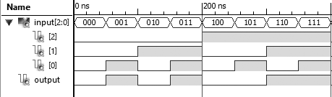

1. Activity VI

Write VHDL code to implement a 4-bit adder/subtracter using four 1-bit full adders

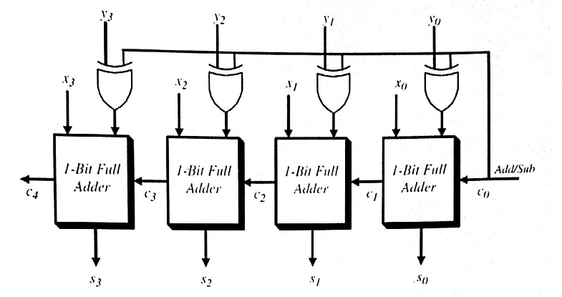

Fig. 4-bit adder/subtracter using 1-bit Full Adder

`TABLE – V

Truth Table for 1-bit Full Adder

|  |  |  |  |  |
| --- | --- | --- | --- | --- |
| **Input Bits** | | | **Output** | |
| **X** | **Y** | **Carry (Cin)** | **Carry (Cout)** | **Sum (S)** |
| 0 | 0 | 0 | 0 | 0 |
| 0 | 0 | 1 | 0 | 1 |
| 0 | 1 | 0 | 0 | 1 |
| 0 | 1 | 1 | 1 | 0 |
| 1 | 0 | 0 | 0 | 1 |
| 1 | 0 | 1 | 1 | 0 |
| 1 | 1 | 0 | 1 | 0 |
| 1 | 1 | 1 | 1 | 1 |

$S=X⊕Y ⨁ Cin$ and $Cout=XY+(X⊕Y) Cin$

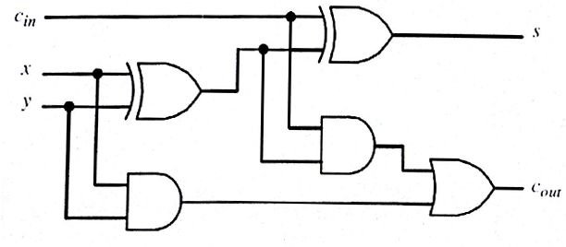

Fig. Logic Circuit for 1-bit Full Adder

Use structural architecture style with hierarchical design approach. Use 1-bit adder as the basic building block. Implement the 4-bit adder/subtracter using four 1-bit full adders. Write a VHDL test bench to verify the operation of the 4-bit adder/subtracter. Provide a simulation waveform depicting all possible input cases.

**VHDL Code:**

**[xor1.vhd]**

LIBRARY IEEE;

USE IEEE.STD_LOGIC_1164.ALL;

ENTITY xor1 IS PORT (

i1, i2: IN STD_LOGIC;

o1: OUT STD_LOGIC

);

END xor1;

ARCHITECTURE dataflow OF xor1 IS

BEGIN

o1 <= i1 XOR i2;

END dataflow;

**[full_adder.vhd]**

LIBRARY IEEE;

USE IEEE.STD_LOGIC_1164.ALL;

ENTITY full_adder IS PORT (

i1, i2, cin: IN STD_LOGIC;

sum, cout: OUT STD_LOGIC

);

END full_adder;

ARCHITECTURE dataflow OF full_adder IS

BEGIN

sum <= i1 XOR i2 XOR cin;

cout <= (i1 AND i2) OR ((i1 XOR i2)

AND cin);

END dataflow;

**[add_sub_structural.vhd]**

LIBRARY IEEE;

USE IEEE.STD_LOGIC_1164.ALL;

ENTITY add_sub IS PORT (

X3, X2, X1, X0: IN STD_LOGIC;

Y3, Y2, Y1, Y0, A_S: IN STD_LOGIC;

S4, S3, S2, S1, S0: OUT STD_LOGIC

);

END add_sub;

ARCHITECTURE structural OF add_sub IS

SIGNAL F0, F1, F2, F3: STD_LOGIC;

SIGNAL C1, C2, C3 : STD_LOGIC;

COMPONENT xor1 IS PORT (

i1, i2: IN STD_LOGIC;

o1: OUT STD_LOGIC

);

END COMPONENT;

COMPONENT full_adder IS PORT (

i1, i2, cin: IN STD_LOGIC;

sum, cout: OUT STD_LOGIC

);

END COMPONENT;

BEGIN

A0: xor1 PORT MAP (i1 => A_S, i2 =>

Y0, o1 => F0);

A1: full_adder PORT MAP (i1 => X0, i2 => F0, cin => A_S, sum => S0, cout => C1);

A2: xor1 PORT MAP (i1 => A_S, i2 =>

Y1, o1 => F1);

A3: full_adder PORT MAP (i1 => X1, i2 => F1, cin => C1, sum => S1, cout => C2);

A4: xor1 PORT MAP (i1 => A_S, i2 =>

Y2, o1 => F2);

A5: full_adder PORT MAP (i1 => X2, i2 => F2, cin => C2, sum => S2, cout => C3);

A6: xor1 PORT MAP (i1 => A_S, i2 =>

Y3, o1 => F3);

A7: full_adder PORT MAP (i1 => X3, i2 => F3, cin => C3, sum => S3, cout => S4);

END structural;

**Test Bench**

LIBRARY IEEE;

USE IEEE.STD_LOGIC_1164.ALL;

USE IEEE.NUMERIC_STD.ALL;

ENTITY add_sub_tb IS

END add_sub_tb;

ARCHITECTURE behavioral OF add_sub_tb IS

COMPONENT add_sub

PORT(

X3, X2, X1, X0: IN STD_LOGIC;

Y3, Y2, Y1, Y0: IN STD_LOGIC;

A_S: IN STD_LOGIC;

S4,S3,S2,S1,S0: OUT STD_LOGIC

);

END COMPONENT;

SIGNAL addsub: STD_LOGIC := '0';

SIGNAL input_vector1: STD_LOGIC_VECTOR( 3 DOWNTO 0) := "0000";

SIGNAL input_vector2: STD_LOGIC_VECTOR( 3 DOWNTO 0) := "0000";

SIGNAL output_vector: STD_LOGIC_VECTOR( 4 DOWNTO 0) := "00000";

BEGIN

uut: add_sub PORT MAP(

A_S => addsub,

X3 => input_vector1(3),

X2 => input_vector1(2),

X1 => input_vector1(1),

X0 => input_vector1(0),

Y3 => input_vector2(3),

Y2 => input_vector2(2),

Y1 => input_vector2(1),

Y0 => input_vector2(0),

S4 => output_vector(4),

S3 => output_vector(3),

S2 => output_vector(2),

S1 => output_vector(1),

S0 => output_vector(0)

);

stim_proc: PROCESS

BEGIN

FOR index1 IN 0 TO 15 LOOP

input_vector1 <= std_logic_vector(to_unsigned(index1,4));

FOR index2 IN 0 TO 15 LOOP

input_vector2 <= std_logic_vector(to_unsigned(index2,4));

WAIT FOR 50 ns;

END LOOP;

END LOOP;

END PROCESS;

END behavioral;

Discussion:

To make a 4-bit adder/subtracter, we need extra input, namely add/sub as given in block diagram above. In block diagram, there are two component, XOR gate and 1-bit full adder. So, while implementing using structural style, two components are first defined. 1-bit full adder is designed using AND, OR and XOR gate as per the logic diagram of full adder. These components are then used in structural description of 4-bit full adder. The test bench code that produces output for all possible cases is made to make sure that our design is complete and accurate. Waveforms depicting all possible input cases are included as output for this activity.

Output:

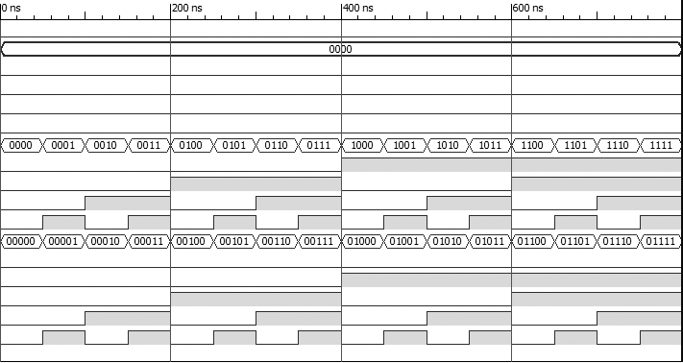

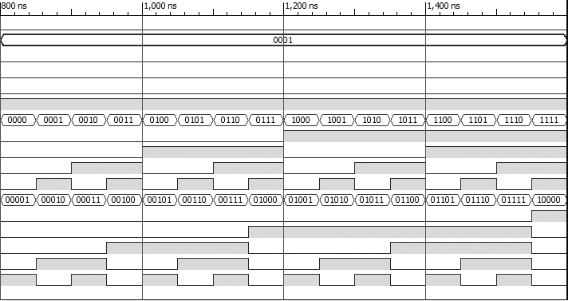

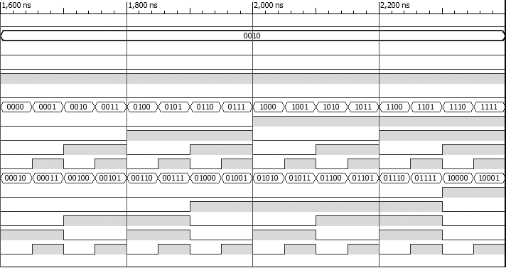

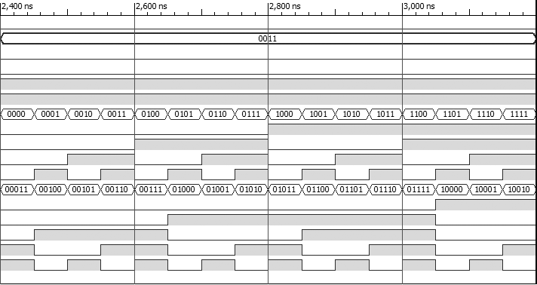

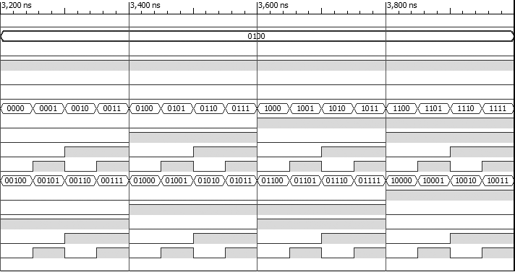

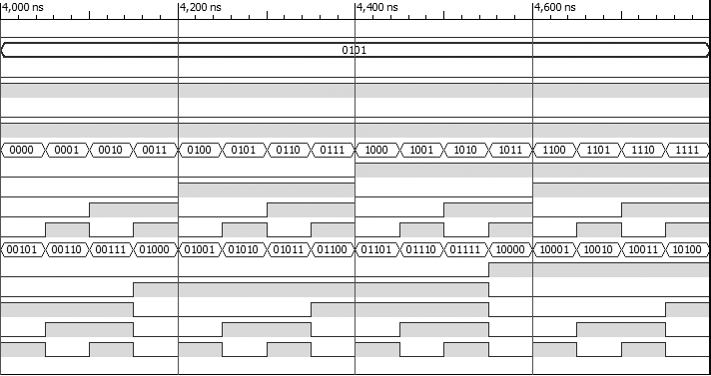

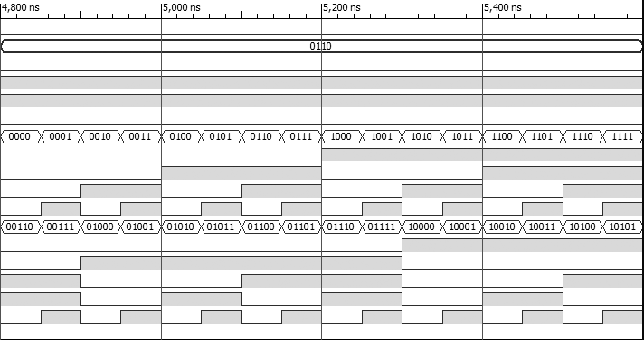

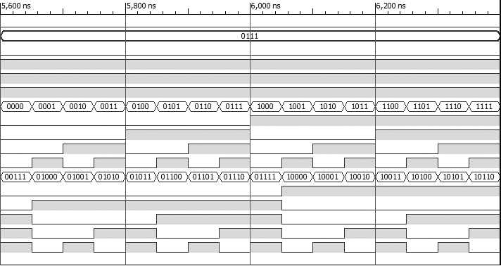

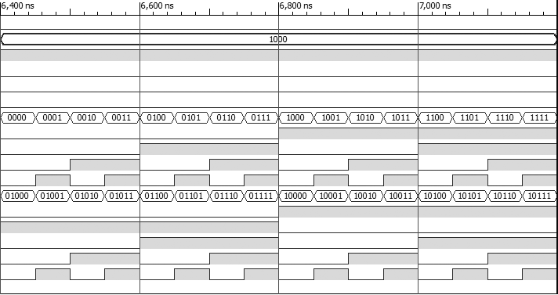

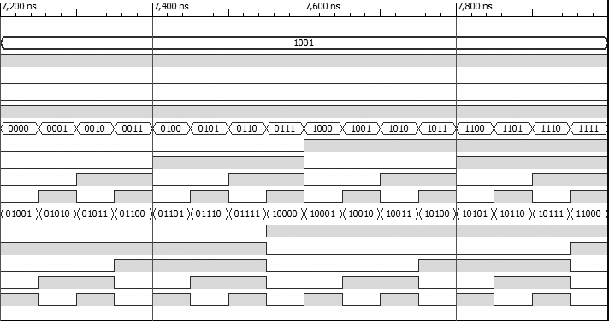

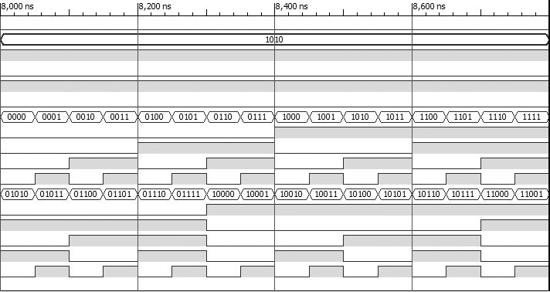

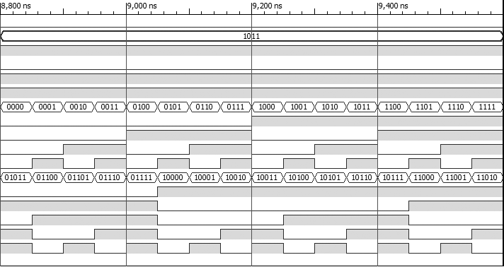

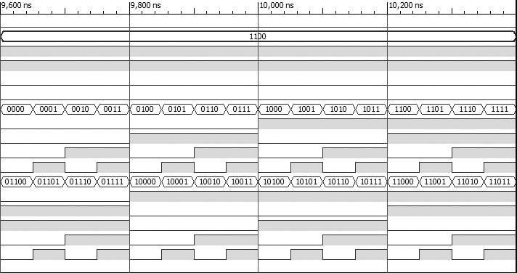

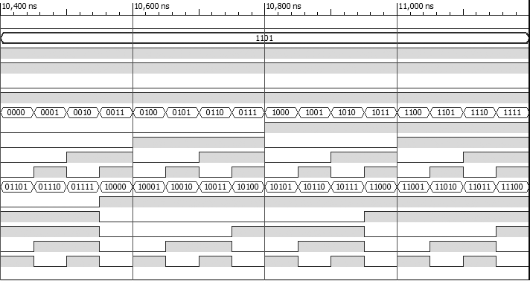

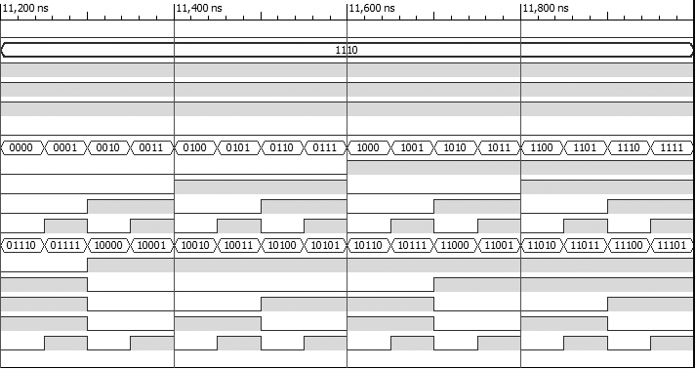

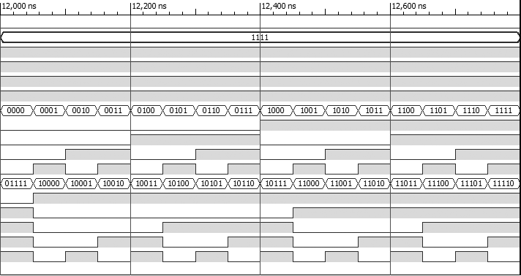

For subtraction:

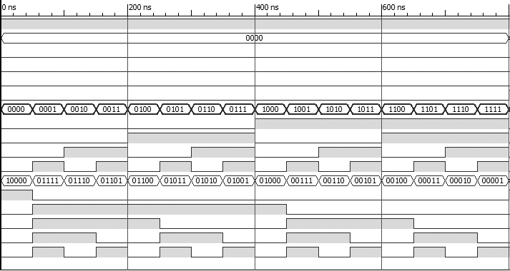

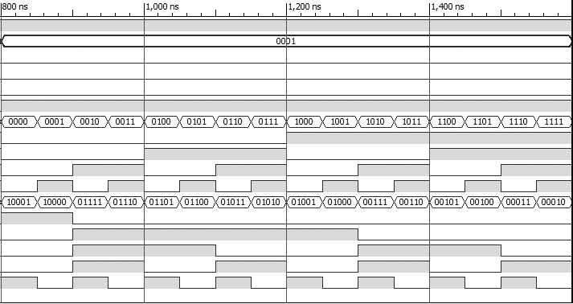

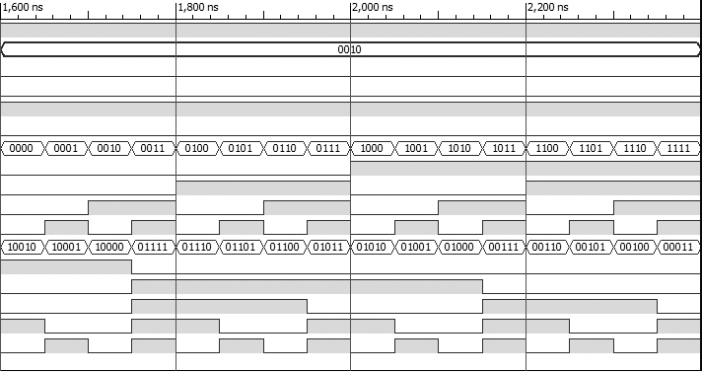

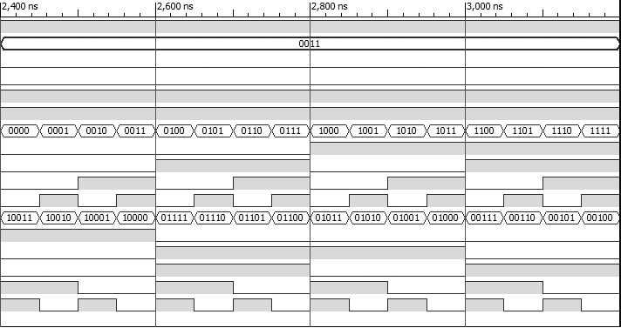

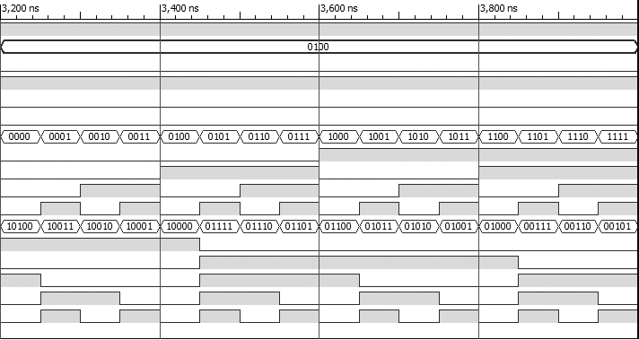

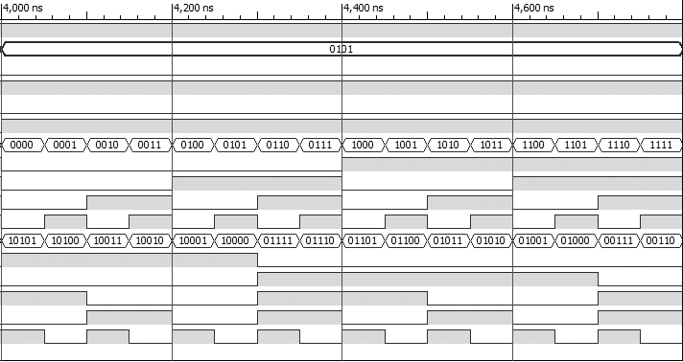

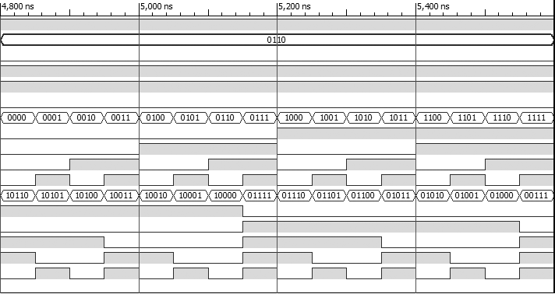

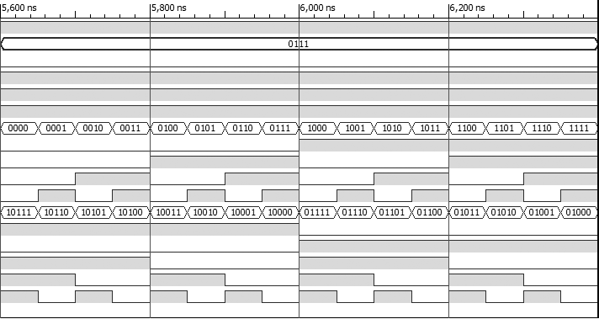

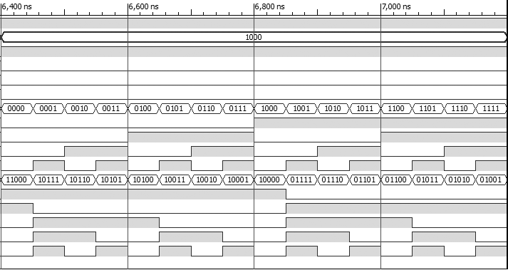

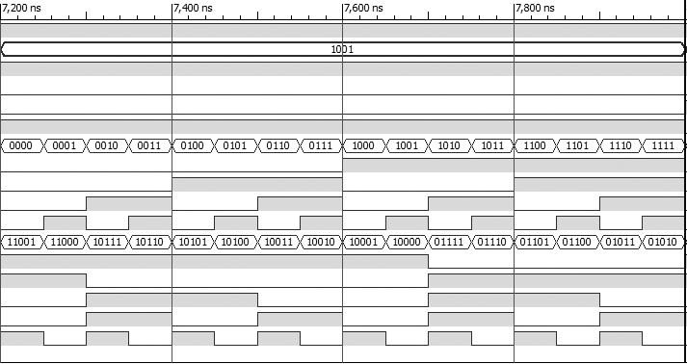

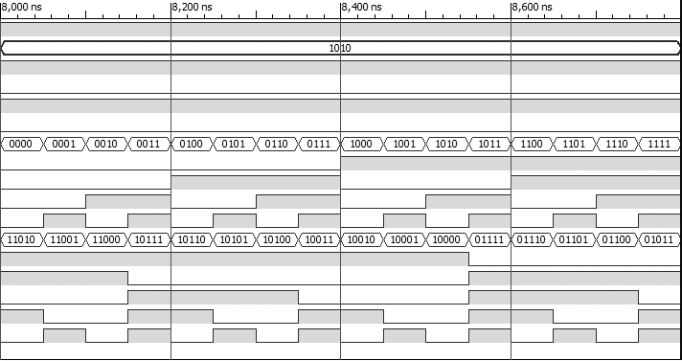

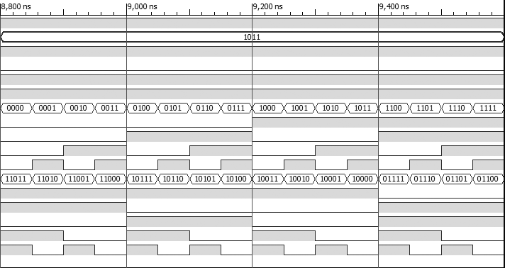

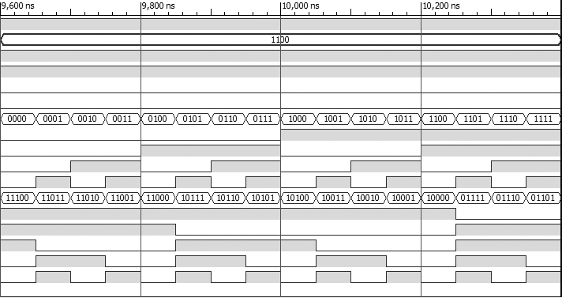

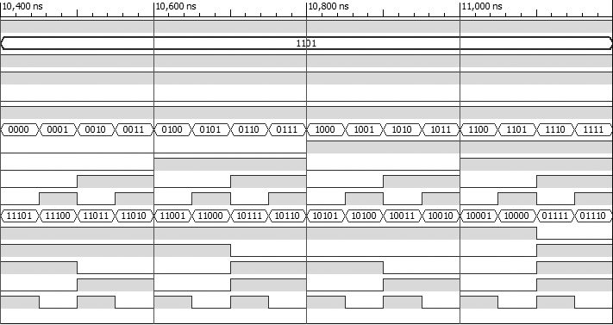

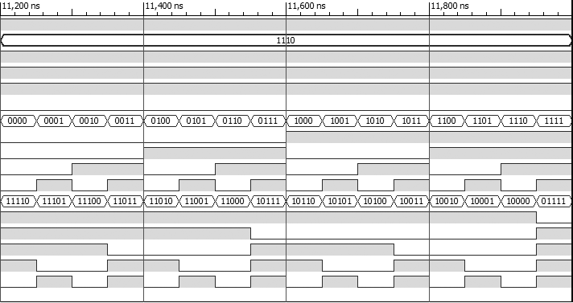

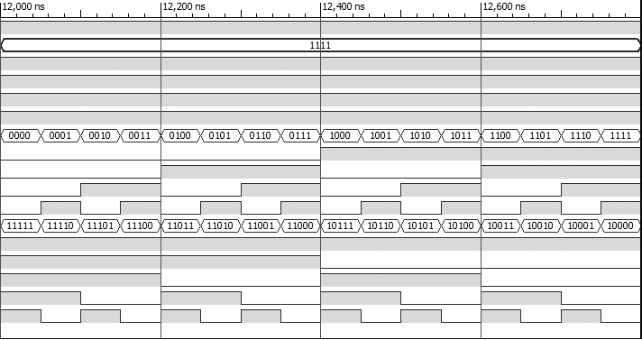

1. Activity VII

Write VHDL code to implement a 4:1 MUX having inputs (x1, x2, x3, and x4), select lines (s1, s0) and output (y) using three 2:1 multiplexers as the basic building blocks.

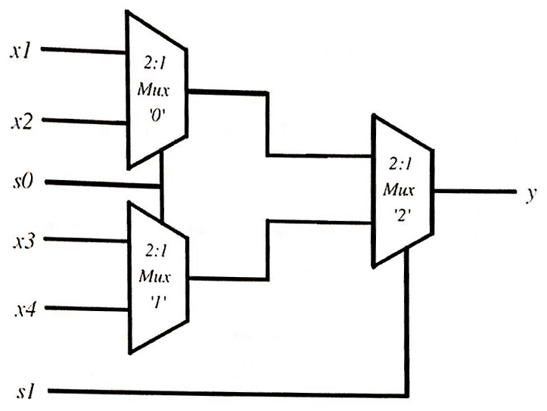

Use a hierarchical design approach. Create component definitions in separate (.vhd) files. Use either Dataflow or Behavioral or Structural design styles. Use structural design style for the 4:1 MUX architecture. Make use of 2:1 MUX component declaration. Make use of 2:1 MUX component instantiation. Write a VHDL test bench to verify the operation of the 4:1 MUX. Provide a simulation waveform depicting all possible input cases.

**VHDL Code:**

**[mux2to1_dataflow.vhd]**

LIBRARY IEEE;

USE IEEE.STD_LOGIC_1164.ALL;

ENTITY mux2to1 IS PORT (

SEL, I1, I2: IN STD_LOGIC;

O: OUT STD_LOGIC

);

END mux2to1;

ARCHITECTURE dataflow OF mux2to1 IS

BEGIN

WITH (NOT SEL AND I1) OR (SEL AND I2) SELECT

O <= '1' WHEN '1',

'0' WHEN '0',

'0' WHEN OTHERS;

END dataflow;

**[mux4to1_structural.vhd]**

LIBRARY IEEE;

USE IEEE.STD_LOGIC_1164.ALL;

ENTITY mux4to1 IS PORT (

X1, X2, X3, X4, S0, S1: IN STD_LOGIC;

Y: OUT STD_LOGIC

);

END mux4to1;

ARCHITECTURE structural OF mux4to1 IS

SIGNAL F1, F2: STD_LOGIC;

COMPONENT mux2to1 IS PORT (

I1, I2, SEL: IN STD_LOGIC;

O: OUT STD_LOGIC

);

END COMPONENT;

BEGIN

M0: mux2to1 PORT MAP (I1 => X1, I2 =>

X2, SEL => S0, O => F1);

M1: mux2to1 PORT MAP (I1 => X3, I2 =>

X4, SEL => S0, O => F2);

M2: mux2to1 PORT MAP (I1 => F1, I2 =>

F2, SEL => S1, O => Y);

END structural;

**Test bench**

LIBRARY IEEE;

USE IEEE.STD_LOGIC_1164.ALL;

USE IEEE.NUMERIC_STD.ALL;

ENTITY mux4to1_tb IS

END mux4to1_tb;

ARCHITECTURE behavioral OF mux4to1_tb IS

COMPONENT mux4to1

PORT(

X1, X2, X3, X4: IN STD_LOGIC;

S0, S1: IN STD_LOGIC;

Y: OUT STD_LOGIC

);

END COMPONENT;

SIGNAL select_vec: STD_LOGIC_VECTOR( 1 DOWNTO 0) := "00";

SIGNAL input_vec: STD_LOGIC_VECTOR( 3 DOWNTO 0) := "0000";

SIGNAL output: STD_LOGIC := '0';

BEGIN

uut: mux4to1 PORT MAP(

S0 => select_vec(0),

S1 => select_vec(1),

X1 => input_vec(3),

X2 => input_vec(2),

X3 => input_vec(1),

X4 => input_vec(0),

Y => output

);

stim_proc: PROCESS

BEGIN

FOR selector IN 0 TO 3 LOOP

select_vec <= std_logic_vector (to_unsigned(selector,2));

FOR index IN 0 TO 15 LOOP

input_vec <= std_logic_vector(to_unsigned(index,4));

WAIT FOR 50 ns;

END LOOP;

END LOOP;

END PROCESS;

END behavioral;

Discussion:

In this activity, we need to make 4:1 multiplexer using three 2:1 multiplexers as shown in the logic diagram. So, for the component declaration, simple dataflow style is used and for 4:1 multiplexer description, hierarchical structural design style is used as instructed. In 4:1 multiplexer, there are six inputs, four input lines and two select lines required to choose one of four input lines. Single output of 4:1 multiplexer is used to provide any one of four input specified by bit pattern of select lines. A VHDL test bench is made to simulate the operation of 4:1 multiplexers for all possible input cases. Waveform for all possible case is given below as output.

Output:

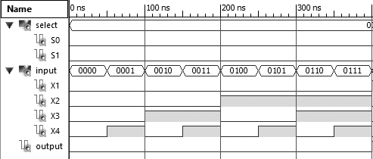

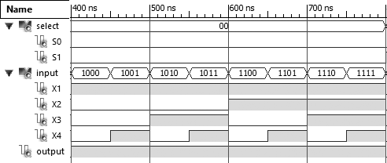

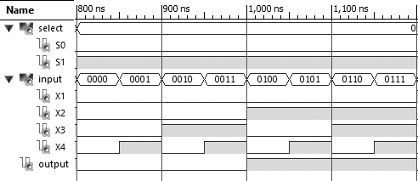

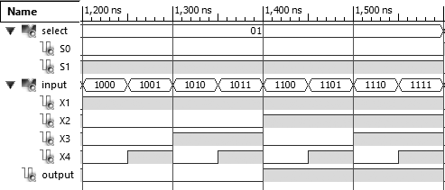

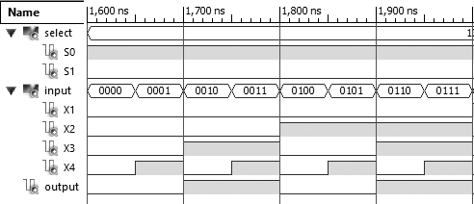

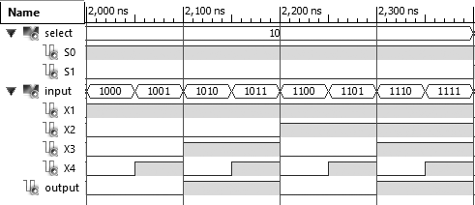

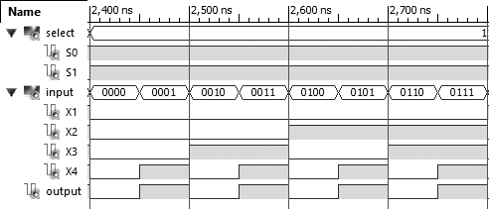

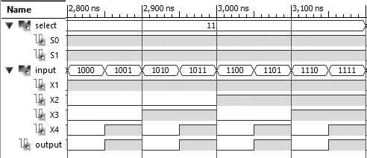

Conclusion

Various activities concerned VHDL programming were done in this lab. Different logic circuits were designed in different styles as instructed using Xilinx ISE Design Suite. Required truth table along with Karnaugh map simplification is shown in this report. VHDL codes to all activities are included in this report. Waveform depicting all cases for all activities are included as output.

Acknowledgment

This lab report is prepared as a document for activities done in lab concerned with combinational logic design using VHDL programming. This report is made accurate and professional as far as possible. I would like to express our deepest gratitude to our teacher, Mr. Dinesh Baniya Kshatri, for guiding us in the practical. I am very grateful to the Department of Electronics and Computer Engineering (DoECE) of IOE Central Campus, Pulchowk for arranging such a schedule on our academic side.

References

[1] (2016) The Wikipedia website. [Online]. Available: <https://en.m.wikipedia.org/wiki/VHDL/>

[2] P. J. Ashenden, The VHDL Cookbook [portable document]. Available: <http://www.cs.adelaide.edu.au/>

[3] D. Kshatri, Combinational Logic Design using VHDL [scanned document]. Available: Offline.

[4] S. Shrestha, VHDL [presentation]. Available: Offline